1. Which of the following pairs of quantities are both scalar?

- Speed, velocity

- Current, charge

- Gravitation potential, gravitational field

- Pressure, force

2. A transverse wave propagates with a speed of v in a stretched string of tension, T. Mass per unit length of the string is m. Which of the following equation is homogeneous?

A. v = 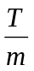 B. v = 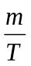 C. v = 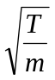 D. v = 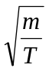

3.
horizontal surface
20 ms⁻¹
20 ms⁻¹

A ball collided with a horizontal surface at an angle of 45º and rebounded with the same speed and at the same angle to the surface. What is the change in velocity of the ball?

- 28.3 ms⁻¹ upward, normal to the surface

- 40.0 ms⁻¹ to the right

- 28.3 ms⁻¹ downward, normal to the surface

- 40.0 ms⁻¹ downward, normal to the surface

4.

A B

A projectile of mass, m is fired with velocity, u from a point A. Neglecting air resistance, the magnitude of the change in momentum between leaving A and arriving at B is

A. mu

- zero

- mu

- 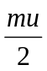

- The resistance X of an unknown resistor is measured by finding the potential difference across it and the current through it. If the readings of the potential difference and current are (2.00 ± 0.02) V and ( 5.3 ± 0.1) mA respectively, the resistance X should be quoted as

- (377.4 0.1) Ω
- (380 10) Ω
- (377.36 0.01) Ω
- (377.358 0.001) Ω

- A stationary radioactive nucleus decays leaving behind a daughter nucleus of mass M₁ and a particle of mass M₂. The daughter nucleus and the particle move off in opposite directions with speeds v₁ and v₂ respectively. What is the ratio of

Kinetic energy of particle ?
Kinetic energy of daughter nucleus

A. 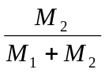 B. 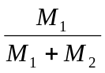 C. 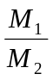 D. 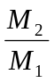

7.
An object on a smooth surface is acted by a force, F. Its magnitude changes as shown in the graph. Which of the graphs of velocity, v against time, t below represents correctly the motion of the object is correct?

Time, t/s
Force, F/ N
T

A. B.
T
t/ s
v/ ms⁻¹
T
t/ s
v/ ms⁻¹

C. D.
T
t/ s
v/ ms⁻¹
T
t/ s
v/ ms⁻¹

  - An object suspended from a string is fully immersed in water in a beaker, resting on a scale balance. The force, according to Newton’s Third Law, which forms an actions-reaction pair with the force that the object exerts downwards on the water in the beaker is
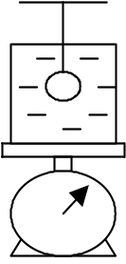

- the tension in the string.
- the upthrust on the object.
- the weight of the object.
- the force, which the beaker containing the water exerts on the scale balance.

  - An object of weight 100 N registers a value of 80 N by a spring balance when the lift is moving. Which of the following situations is possible?
- The lift is decelerating and moving upwards.
- The lift is moving at constant velocity.
- The lift is decelerating and moving downwards.
- The lift is accelerating and moving upwards.

10. The motor which drives a lift is working at 84 % of its maximum power. The mass of the lift and its load is 600 kg, and they are moving vertically upwards at a constant speed of 5 ms⁻¹. What is the maximum power of the motor ?

A. 35.0 kW | B. 58.9 kW | C. 75.8 kW | D. 15.0 kW

11. An object accelerates uniformly when the resultant force acting on it

  - is zero

  - is proportional to the displacement from a fixed point

  - is constant but not zero

  - increases uniformly with respect to time

12. During the time between a parachutist leaving a plane and reaching the
ground safely
    - the sum of her gravitational potential energy and her kinetic energy is constant
    - her kinetic energy depends upon her velocity
    - her gravitational potential energy is proportional to her height
above the ground.
Which of A, B, C and D shows the correct answers ?

A. 1,2,3 | B. 1,2 | C. 2,3 | D. 1

13. A spanner is used to tighten a nut as shown.

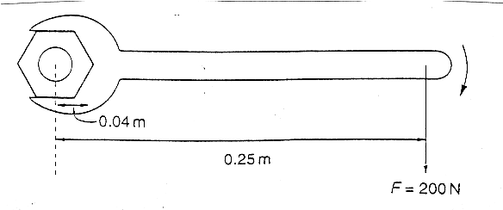

A force F is applied at right angles to the spanner at a distance of 0.25 m from the center of the nut. When the nut is fully tightened, the applied force is 200 N. What is the resistive torque, in an anticlockwise direction, preventing further tightening?

A. 50 Nm | B. 75 Nm | C. 100 Nm | D. 150 Nm

14. Two parallel forces F act in opposite directions along the sides AD and CB of
F
F
D
C
4 N
0.6 m
4 N
B
A
0.4 m
a rectangular horizontal plate ABCD as shown.

What is the magnitude of F ?

A. 3 N | B. 6 N | C. 12 N | D. 18 N

15. A force of 8 N acts horizontally on a stationary mass of 2 kg for 4 s. The kinetic energy gained by the two masses in J is ?

A. 144 | B. 256 | C. 72 | D. 48

16. A boat moving at constant speed ν through still water experiences a total frictional drag, F. What is the power developed by the boat ?

A. 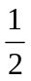Fv | B. Fv² | C. Fv² | D. Fv

17. The mechanical power output by the engine of a particular car is 18.6 kW at a steady speed of 100 kmh⁻¹. What is the magnitude of the total force opposing the motion of the car ?

A. 670 N | B. 1860 N | C. 1860 kN | D. 6700 N

18. A lunar landing module is descending to the Moon’s surface at a steady velocity of 10 ms⁻¹. At a height of 120 m, a small object falls from its landing gear. Taking the Moon’s gravitational acceleration as 1.6 ms⁻², at what speed does the object strike the Moon?

A. 30 ms⁻¹ | B. 22 ms⁻¹ | C. 20 ms⁻¹ | D. 17 ms⁻¹

19. The velocity of a particle that is decelerating uniformly changes from 40 ms⁻¹ to 25 ms⁻¹ in 75 meter. After what further distance will it come to rest?

A. 48.1 m | B. 37.5 m | C. 75.0 m | D. 50.3 m

- A Young’s double slit interferometer is illuminated with green light of wavelength 546 nm. The double slits are 0.100 mm apart and the screen is 20.0 cm away from the double slits. What is the distance on the screen, between the two consecutive bright fringes?

A. 1.09 mm | B. 4.36 mm | C. 1.09 cm | D. 6.00 mm

- Which one of the following groups of electromagnetic waves is in the order of decreasing wavelength?
- Gamma rays, ultra-violet, radio-waves
- Gamma rays, visible light, ultra-violet
- Microwaves, ultra-violet, X-rays
- Visible light, infra-red, X-rays.

- S₁ and S₂ are loudspeakers facing each other and emitting continuous sound waves of frequency 1100 Hz. M is a small microphone, which runs on straight track between S₁ and S₂ at a speed of 30 m s⁻¹. The velocity of sound is 330 ms⁻¹. The sound received by M will fluctuate with a frequency of

A. 100 Hz | B. 200 Hz | C. 400 Hz | D. 800 Hz

- S₁ and S₂ are two coherent sources of waves which are equidistant from P. Operating alone, S₁ produces waves of intensity I at P while S₂ produces waves of intensity I at P. When both are operating in phase, the resultant intensity of waves at P is

A. 2 I | B. 3 I | C. 4 I | D. 5 I

24. A wave with a frequency of 3.0 x 10¹⁴ Hz passes through a point. What is the number of wavelength that passes through that point in a second?

A. 3.0 x 10¹⁴

- 0.3 x 10⁻¹⁴

C. 1.0 x 10⁻⁶

D. 1.0 x 10⁶
25. Which one of the following statements correctly describes the relationship between two consecutive antinodes in a standing wave?

A. Their oscillations are in phase with each other.

B. Both will pass their equilibrium positions with opposite velocities.

C. When one has maximum kinetic energy, the other antinode has maximum
potential energy.

D. Both have minimum energy since the amplitude of oscillations is minimum.

26. Wave generators S₁ and S₂ generate sinusoidal waves of equal frequency but of amplitudes 2a and a respectively. The wavetrains from S₁ and S₂ arrive at point P with a path difference of ½λ. Which of the following correctly shows the resultant oscillation at P if S₁ and S₂ operate with a phase difference of π radian?

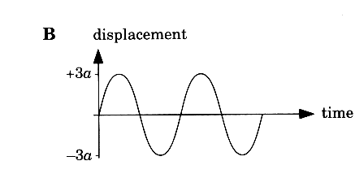
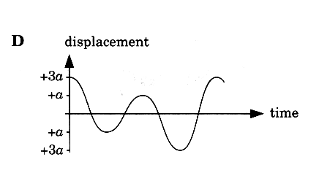
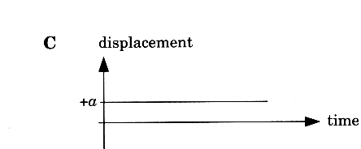
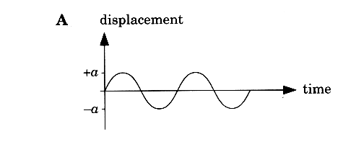

27. In an experiment to demonstrate Brownian motion, smoke particles in a
container are illuminated by a strong light source and observed through a
microscope. The particles are seen as small specks of light that are in random motion.
What causes this motion?

- collisions between the smoke particles and the walls of the container

- collisions between the smoke particles and air molecules

- convection currents within the air as it is warmed by the light source

D. Kinetic energy gained by the smoke particles on absorption of light

28. The graph shows how the pressure exerted by a liquid varies with depth
below the surface.
0
1000
2000
Pressure/ Pa
3000
Depth/m
0.1
0.2
0.3
0.4

What is the density of the liquid?

- 6000 kgm⁻³

- 7500 kgm⁻³

- 760 kgm⁻³

- 600 kgm⁻³

29. What is the ultimate tensile stress of a material?

A. the stress at which the material reaches its elastic limit

B. the stress at which the material becomes ductile

C. the stress at which the material deforms plastically

D. the stress at which the material breaks

30. A power station has an efficiency of 40 % and generates 1000 MW of electrical power. What are the input power and the wasted power?

 | Input power/MW | Wasted power/MV
A | 1000 | 400
B | 1000 | 600
C | 2500 | 1500
D | 1400 | 400

31. What is the working resistance of a light bulb with a power rating P at the operating voltage V?

A. P/V | B. (P/V)² | C. V/P² | D. V²/P

32. A wire carries a current of 2.0 amperes for 1 hour. How many electrons pass a
point in the wire in this time ?

- 1.2 x 10 ^{–15}

B. 4.5 x 10²²

C. 7.2 x 10³

D. 1.3 x 10¹⁹

33. The graph shows the variation with potential difference V of the current I, for an electrical component. Which graph shows the variation with V of the resistance R of the component?
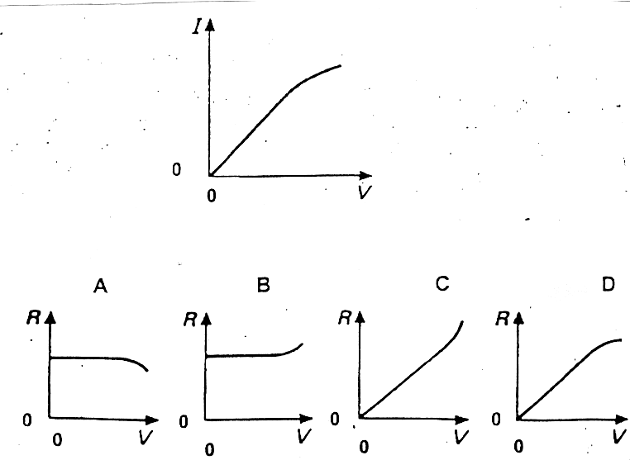

34. In the circuit shown, a potential difference of 2V is applied across XY.

3 Ω
5 Ω
4 Ω
4 Ω
Y
X

What is the current through the 3 Ω resistor?

A. 1/4 A | B. 3/4 A | C. 3/5 A | D. 3/8 A

35. The circuit diagram shows a network of resistors, each of resistance R.

X
Y

What is the effective resistance between the points X and Y ?

A. 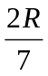 | B. 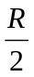 | C. 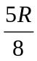 | D. 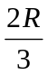

36. The diagram shows currents I₁, I₂, I₃, I₄ and I₅ in the different branches
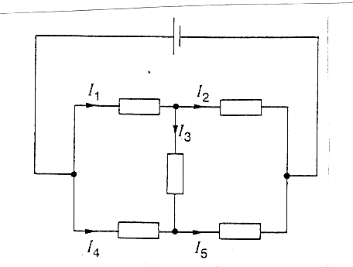
of a circuit.

Which one of the following is correct?

- I₁ = I₂ + I₃

- I₂ = I₁ + I₃

- I₃ = I₄ + I₅

- I₄ = I₅ + I₃

37. A potential difference V is applied between two parallel plates a small
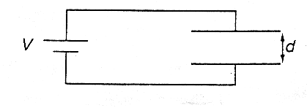
d apart, and produces an electric field of strength E between the plates.

What is the electric field strength between the plates when both V and d
are doubled?

A. E | B. 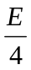 | C. 2E | D. 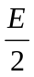

38. Which set of radioactive emissions in the table corresponds to the definitions given in the headings?

high-speed high-speed high-frequency
electrons helium nuclei electromagnetic waves

- α β⁻ γ

- α γ β⁻

- β⁻ α γ

D. β⁻ γ α

39. 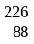Ra decays through a series of transformations to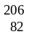Pb. These transformations involve the emissions of both α-particle and β-particles. What is the total number of β-particles emitted?

A. 4 | B. 6 | C. 14 | D. 18

40. Protons and neutrons are thought to consist of smaller particles called quarks. The ‘up’ quark has a charge of e; a ‘down’ quark has charge of -e, where e is the elementary charge (+1.6 x 10⁻¹⁹ C). How many up quarks and down quarks must a proton contain?

Up quarks Down quarks

- 2 1

- 1 2

- 1 1

- 0 3

